HOLSTON VALLEY UNITARIAN UNIVERSALIST CHURCH
2021 CONGREGATIONAL MEETING MINUTES

Date: April 25, 2021 Place: Zoom due to Covid-19

Called to order at 12:05pm Previous Minutes Reviewed? Yes

Presiding: Dana York, President Board of Trustees

Parliamentarian: Wendy Hearl, Programs Trustee

A quorum of the church membership attended. Yes
Official # of church members on 4/26/21 = 113
Quorum = 35% (due to calling a new minister)= 40 members
In attendance: 67 members

MADE BY | SECOND | MOTIONS | ENACTED?
Ann Livengood | Wendy Hearl | I move that the congregation approve the minutes of the May 2020 Congregational Meeting. | Yes
Board | No 2nd needed | We move that the slate of nominees be approved by acclamation.  :  President: Ann Livengood  Vice President: Ann Johnson  Past President: Dana York  Programs Trustee: Bryan Kleske  Secretary: Dottie Blades  Stewardship Trustee: Charlie Miller (continuing)  Facilities Trustee: Greg Kramer (continuing)  Treasurer: Deb Helmer (continuing)  Membership Trustee: Michele Markstrom-Frisch (continuing)  Nominating Committee 2021-2022:  Joy Boyd, Cynthia Goodman, and Tish Kashdan, (all 2 year terms) and Lance Kloosterman (1 year to replace Lee Sinnott who is not continuing on the Committee)  Judy Tucker (Chair Person) has another year on her term | Yes
Board | No Second needed | I move that HVUUC accept this 2021-2022 operating budget. (see below) | Yes
Dottie Blades | No Second needed | In accordance with our bylaws, and on behalf of the Search Committee, I move that we call Reverend Tiffany Sapp to settled ministry. (Effective August 1, 2021) | Yes

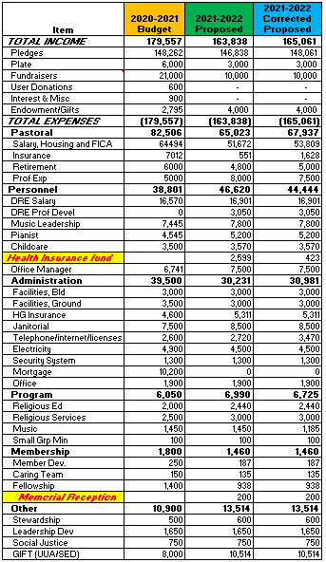

Discussion during budget presentation:

Clarification that a Music Director is funded on this budget occurred. Tiffany Sapp’s salary was discussed including her Health Insurance will not be paid by the Church at this time due to being on her husband’s plan (though the church is prepared to take up this cost if needed in the future).

The meeting adjourned at 12:59pm

