HOLSTON VALLEY UNITARIAN UNIVERSALIST CHURCH
2022 CONGREGATIONAL MEETING MINUTES

Date: April 24, 2022 Place: Zoom due to Covid-19

Called to order at 12:01pm Previous Minutes Reviewed? Yes

Presiding: Ann Livengood, President Board of Trustees

Parliamentarian: Wendy Hearl

Ann welcomed everyone to the Annual Meeting, and explained the Zoom Ground Rules. She shared today’s Agenda on the Zoom screen.

Official # of church members on 4/24/22 = 111
Quorum = 30%
In attendance: 54 members
A quorum of the church membership attended. Yes

MADE BY | SECOND | MOTIONS | ENACTED?
Spencer Conco | Dana York | I move that we accept the 2021 Annual Meeting minutes as presented. | Yes
Judy Tucker | No 2nd needed | I move that the slate of nominees proposed by the Nominating Committee for 2022-2023 be approved.  President: Ann Johnson  Vice President: Dottie Blades  Past President: David Kashdan  Secretary: Michele Markstrom-Frisch (1yr finishing Dottie’s term)  Treasurer: Deb Helmer (new term)  Facilities Trustee: Doug Chaffin  Membership Trustee: Cynthia Goodman  Programs Trustee: Bryan Kleske (continuing)  Stewardship Trustee: Charlie Miller (continuing)  Nominating Committee 2022-2023:  Alicia Culbertson (new term)  Josh Beckett (new term)  Linda McCoy (1 year – replacing Cynthia Goodman)  Joy Boyd (Chair) (continuing)  Tish Kashdan (continuing) | Yes
Charlie Miller | No 2nd needed | I move that HVUUC accept the 2022-2023 Annual Budget be approved as presented by the Board of Trustees. (see below) | Yes
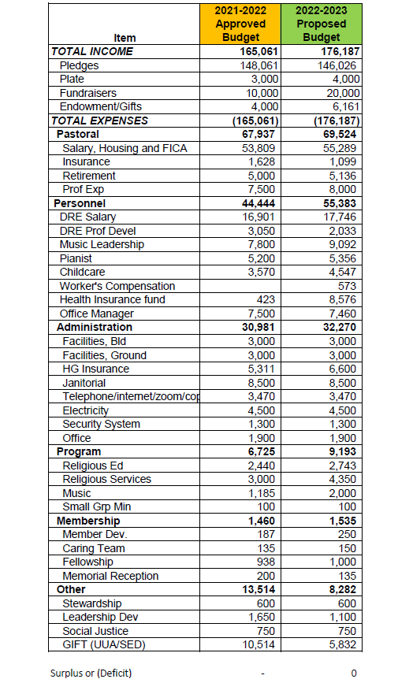
Discussion during budget presentation: How was additional income calculated? What is available in the capital reserve? These questions were answered.

Deb Helmer thanked Ramesh Munjal for his years of service to the HVUUC treasury.

Ann L thanked board members rolling off and continuing.

Joseph Viola asked if it was possible to add new business requesting Jeff Briere become a Minister Emeritus with HVUUC. This will be researched and discussed at a later date.

Ann made a motion to adjourn the Annual Meeting. Dana made the second. The meeting adjourned at 12:39 pm with a unanimous vote.

