HVUUC COVID-19 RESPONSE PLAN August 2022
The COVID-19 virus continues to mutate, with each new variant behaving differently from the last. Vaccines are now available for everyone 6 months and older, and have proven to be quite effective at mitigating serious illness. Science learns more each day about the virus, how it works, and how best to protect ourselves and others from catastrophic illness. Our goal is to provide safe & supportive ways to maintain fellowship, for this pandemic is going to be with us for the foreseeable future. This plan will evolve as science and circumstances dictate.
The UUA urges congregations to follow these basic tenets:
- Base decisions on the values of inclusion and consent.
- Follow the science.
- Go slow and be flexible.
- Be realistic with expectations of ourselves and others.
Our plan for in-person worship at HVUUC is based on CDC and UUA guidance. It considers, in part, metrics reported by covidactnow.org and data.tennessean.com. But numbers alone do not tell the whole story, and cannot be the sole source of our decision-making process.
The Board-appointed Risk Assessment Team determines HVUUC’s Risk Level each Thursday and publishes our current Risk Level & the accompanying decision to hold in-person worship that Sunday or not. They consider metrics as well as other contributing factors, with discretion, when determining risk level. They decide whether to maintain, relax, or tighten restrictions, and field requests for exceptions to the charts. Their decisions are communicated to the congregation via the news tab on the HVUUC.org website, email, HVUUC’s Facebook page, and elsewhere as appropriate.
METRICS TO CONSIDER:
1. Covidactnow.org for the Kingsport Metro area and the Johnson City Metro area
a. DAILY NEW CASES – (7 day average) --the raw number of cases plus the trend (increasing or decreasing)
b. INFECTION RATE – (prior 14 days) Estimated number of new people each COVID-Positive person will infect (less than 0.9 means transmission is decreasing)
c. RISK LEVEL --Low, Medium, High, Very High, and Extremely High
2. Data.tennnessean.org for local hospitals’ capacity
a. INPATIENT BEDS (7 day average) --percentage of beds occupied plus the trend (increasing or decreasing)
b. ICU BEDS (7 day average) --percentage of beds occupied plus the trend (increasing or decreasing)
OTHER CONSIDERATIONS (not an exhaustive list):
1. Our Congregation’s vaccination rate -- Roughly 98% of congregants eligible for vaccination are fully vaccinated.
2. Risk tolerance for our members, lay leaders, and volunteers. --We will continue to offer a quality on-line worship option as well as in-person.
3. Risk tolerance among our staff. Staff and ministers should not be asked to work in person when this puts their lives or health at significant risk (or their household’s health.) –All 4 of our staff have indicated they are able and willing to participate in in-person worship.
4. Relative risk of being in person in our building. Consider the mitigation and standard precautions in place-- ventilation, masking, distancing, hand sanitation, reduced service length, and restrictions on singing, food and beverage. Also congregational compliance with these precautions.
5. Enough volunteers willing and able to show up to make in-person church happen.
STANDARD PRECAUTIONS
1. Vaccinations:
a. All Religious Education teachers and Childcare workers are required to be fully vaccinated.
b. For congregants, our expectation is that if you’re eligible to be vaccinated, you WILL be fully vaccinated. This includes eligible children.
2. Masks: When the risk level chart requires masks: Proper, well-fitting masks are required for everyone in that category who enter church (except a speaker or musician at the podium). Mask must cover mouth & nose at all times. If you do not have a proper mask, you may get one in the foyer before you enter the sanctuary. **Note: bandanas, neck gaiters (buffs), masks with valves, or masks made of porous material are NOT acceptable. The website Projectn95.org is a good resource for mask information and sources.
3. Frequent hand washing/sanitizing --including prior to entry.
4. Social Distancing:
a. Chairs have been positioned in the sanctuary to ensure social distancing between households/pods. PLEASE DO NOT MOVE THEM. There are rows of chairs with 4’ aisles on one side of the sanctuary and smaller groupings of chairs set 6’ apart on the other side, plus a few chairs off by themselves, to allow for folks’ individual comfort levels.
b. The rooms in the REZ and the Fred Ball Room have maximum occupancies posted that group leaders will implement when 6’ distancing is required by the current risk level.
c. When the risk level requires distancing, please maintain social distance when choosing your seat, and avoid gathering/lingering in thoroughfares.
5. Children and youth who remain in the Sanctuary will sit with their adult(s). **Childcare will be provided in the lower level for children 6 months-4 years, during RE and the service.
● If not feeling well, PLEASE STAY HOME. Even if you don’t have COVID-19, you may have another communicable disease.

RISK LEVELS
Risk levels are color-coded Green (low risk), Yellow (medium risk), Orange (high risk), and Red (Severe). The chart outlining actions required at each level is divided according to vaccination status. Keep in mind these are Pandemic Risk Levels. When a credible scientific source declares it safe to do so, the Board will determine appropriate steps to take regarding in-person gathering beyond the scope of this plan.
We realize everyone’s risk tolerance is different. We will continue to offer on-line service options, so everyone who wishes to worship with us can do so safely and comfortably. In the event there is a sudden increase in infection rate or other risk in our community or congregation, we will not hesitate to reinstate previous restrictions or return to virtual services IMMEDIATELY. Our congregation’s health and safety come first!
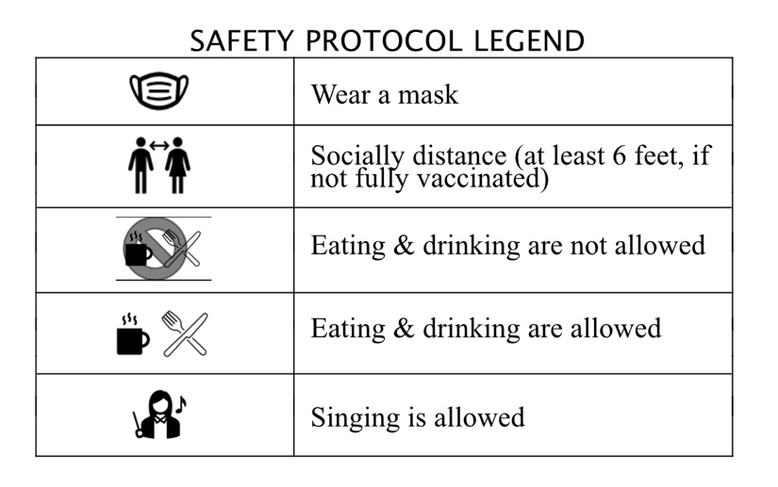
SEVERE
1. Building access restricted:
• Worship service held online via Zoom and YouTube; or outdoors
• Meetings and group gatherings held online via Zoom; or outdoors (with limited approved Indoor exceptions, e.g., Memorial Services, Rentals)
2. Group activities may be held in outdoor areas, or in the building by following the process below for approval/exception:
• Group Leader, Minister, or DRE- submits written request to Risk Assessment Team
• Risk Assessment Team - approves requests
• Secretary - schedules approved activities/groups
3. Group Leader, Minister, or DRE –Responsibilities
• Limit use of building to restrooms only, one person/household/pod at a time (with limited approved exceptions, see above)
• Ensure masks are worn by everyone inside the building, 3 years of age and older, regardless of vaccination status. Exception: staff members in their own offices.
• Ensure masks are worn outside for activities involving close contact with others who are not fully vaccinated
• Limit group size to posted room occupancy, take attendance, and ensure people from different households/pods are spread out (i.e., Social Distance)
• Ensure all refreshments are consumed outside (i.e., masks may not be removed inside). No communal food.
• Disinfect all high-touch surfaces (e.g., door handles, light switches) prior to and following the meeting.
UNVACCINATED | LOCATION | FULLY VACCINATED
 | Outside--Worship
 | Groups Outside
Inside-Restroom, Hallway
**Indoor spaces available to staff & church leaders as required
Approved exceptions only | Groups Inside -- **Must be approved by Risk Assessment Team | Approved exceptions only
NOTE: It is expected that anyone who is sick will STAY HOME.
HIGH
1. Building open for:
• Worship service (with online YouTube option)
• Meetings and group gatherings
• Memorial Services
• Rentals (COVID-19 waiver required)
2. Group Leader, Minister, or DRE –Responsibilities
• Ensure masks are worn by everyone inside the building, 3 years of age and older, regardless of vaccination status. Exception: Vaccinated speakers or musicians (generally limited to 1-2) who have Rapid tested negative may be at the podium unmasked.
• Ensure masks are worn by everyone outside for activities involving close contact with others who are not fully vaccinated
• Limit group size to posted room occupancy, take attendance, and ensure people from different households are spread out (i.e., Social Distance)
• Ensure hand sanitation upon entry.
• Ensure all refreshments are consumed outside. No communal food. (Served, individually wrapped or bring-your-own OK)
• Disinfect all high-touch surfaces (e.g., door handles, light switches) prior to and following the meeting.

UNVACCINATED | LOCATION | FULLY VACCINATED
 | Inside--Worship
 | Groups Outside
ONLY if Group Size does not exceed posted occupancy | Groups Inside
NOTES:
- Inside singing with masks. Exception: 1-2 singers (vaccinated and Rapid-tested negative) permitted unmasked at podium.
- It is expected that anyone who is sick will STAY HOME.
MEDIUM
1. Building open for:
• Worship service (with online Zoom and YouTube option)
• Meetings and group gatherings
• Memorial Services
• Rentals (COVID-19 waiver required)
2. Group Leader, Minister, or DRE –Responsibilities
• Ensure masks are worn inside the building by those not fully vaccinated (3 years of age and older)
• Unless entire group is fully vaccinated, limit group size to posted room occupancy, take attendance, and encourage those not fully vaccinated to maintain Social Distance
• Ensure hand sanitation upon entry.
• Disinfect all high-touch surfaces (e.g., door handles, light switches) prior to and following the meeting.
UNVACCINATED | LOCATION | FULLY VACCINATED
 | Inside - Worship
 | Groups Outside
ONLY if Group Size does not exceed posted occupancy | Groups Inside

NOTES:
1) If a Group member is not fully vaccinated, they must follow “Unvaccinated” safety protocols. Other members may use their discretion.
2) Inside singing with masks. Exception: 1-2 singers permitted unmasked at podium.
3) It is expected that anyone who is sick will STAY HOME.
LOW
1. Building open for:
• Worship service (with online Zoom and YouTube option)
• Meetings and group gatherings
• Memorial Services and other large group multi-generational events
• Rentals (including use of kitchen - renter responsible for disinfecting used surfaces and COVID-19 waiver required)
2. Group Leader, Minister, or DRE – Responsibilities
• Ensure masks are worn inside the building and Social Distance is maintained by those not fully vaccinated (3 years of age and older). If food/beverage allowed, masks removed only briefly while actively taking a bite/sip.
• Ensure hand sanitation upon entry.
• Disinfect all high-touch surfaces (e.g., door handles, light switches) prior to and following the meeting.

UNVACCINATED | LOCATION | FULLY VACCINATED
 | Inside - Worship
 | Groups Outside
ONLY if Group Size does not exceed posted occupancy | Groups Inside

NOTES:
1) If a Group member is not fully vaccinated, they must follow “Unvaccinated” safety protocols. Other members may use their discretion.
2) Inside singing without masks, if fully vaccinated.
3) It is expected that anyone who is sick will STAY HOME.
If we learn that someone who recently attended a service has tested positive for COVID-19, the Board will immediately send an announcement to the congregation (protecting privacy, of course), out of an abundance of caution.
ADDITIONAL MODIFICATIONS (Note: these restrictions will be phased out as appropriate.)
● The heating/air conditioning fans will be turned on an hour before services, to enhance ventilation in the sanctuary.
● Service length reduced to 45 minutes.
● Minister, Service Coordinator, or anyone who will be unmasked at the podium will complete a Rapid Test within 24 hours before the service.
● Candles will be lit by a Caring Team volunteer (indicate candle request from your seat).
● Collection may be taken at doors upon exit rather than passing the bowls hand-to-hand.
● Color-coded armbands will be available to indicate your level of contact comfort.
WRIST BANDS : These are intended to reduce awkward & repeated questions about comfort levels. Choose the appropriate band as you enter, to let folks know how much close interaction you’re comfortable with. Wrist bands will be collected in a bin as you leave so they can be sanitized for the next week.
○ Red = Maintain 6’ distance
○ Yellow = Talking OK, no touch
○ Green = Appropriate touch OK--just ask.
Please note: Patience and grace are two very important gifts we can give one another as we take this journey together. Procedural details will undoubtedly change as the pandemic evolves, science allows, and we find new and better ways to be together.
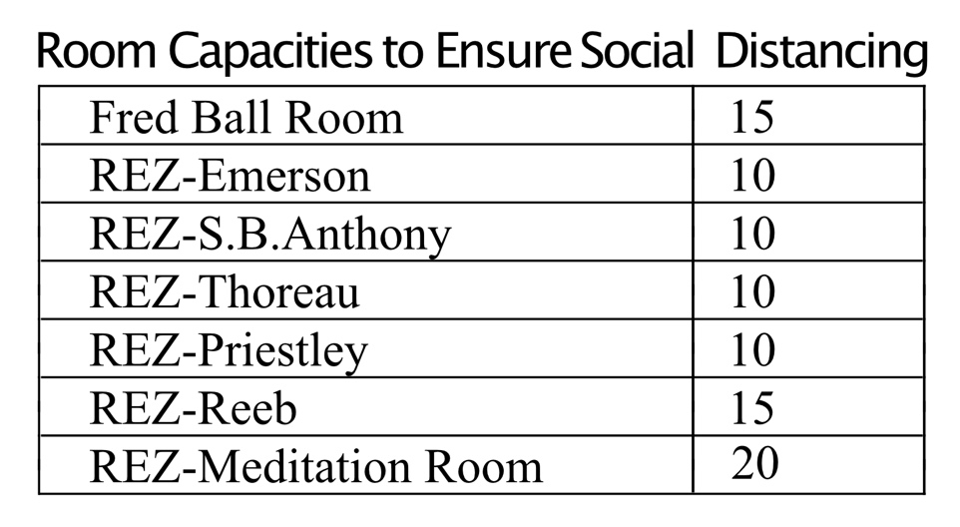
Please Note: If the planned activity or other circumstances dictate, Group Leaders may need to reduce the number of people in the room. Health and safety are paramount.

